|  |  |  |
| --- | --- | --- |
| **AD SOYAD** | **CENGİZHAN TOPÇU** | **KARABÜK ÜNİVERSİTESİ MÜHENDİSLİK FAKÜLTESİ**  **MEKATRONİK MÜHENDİSLİĞİ** |
| **NUMARA** | **2017010225048** |
| **İNTERNET TABANLI PROGRAMLAMA ÖDEV-2** | |

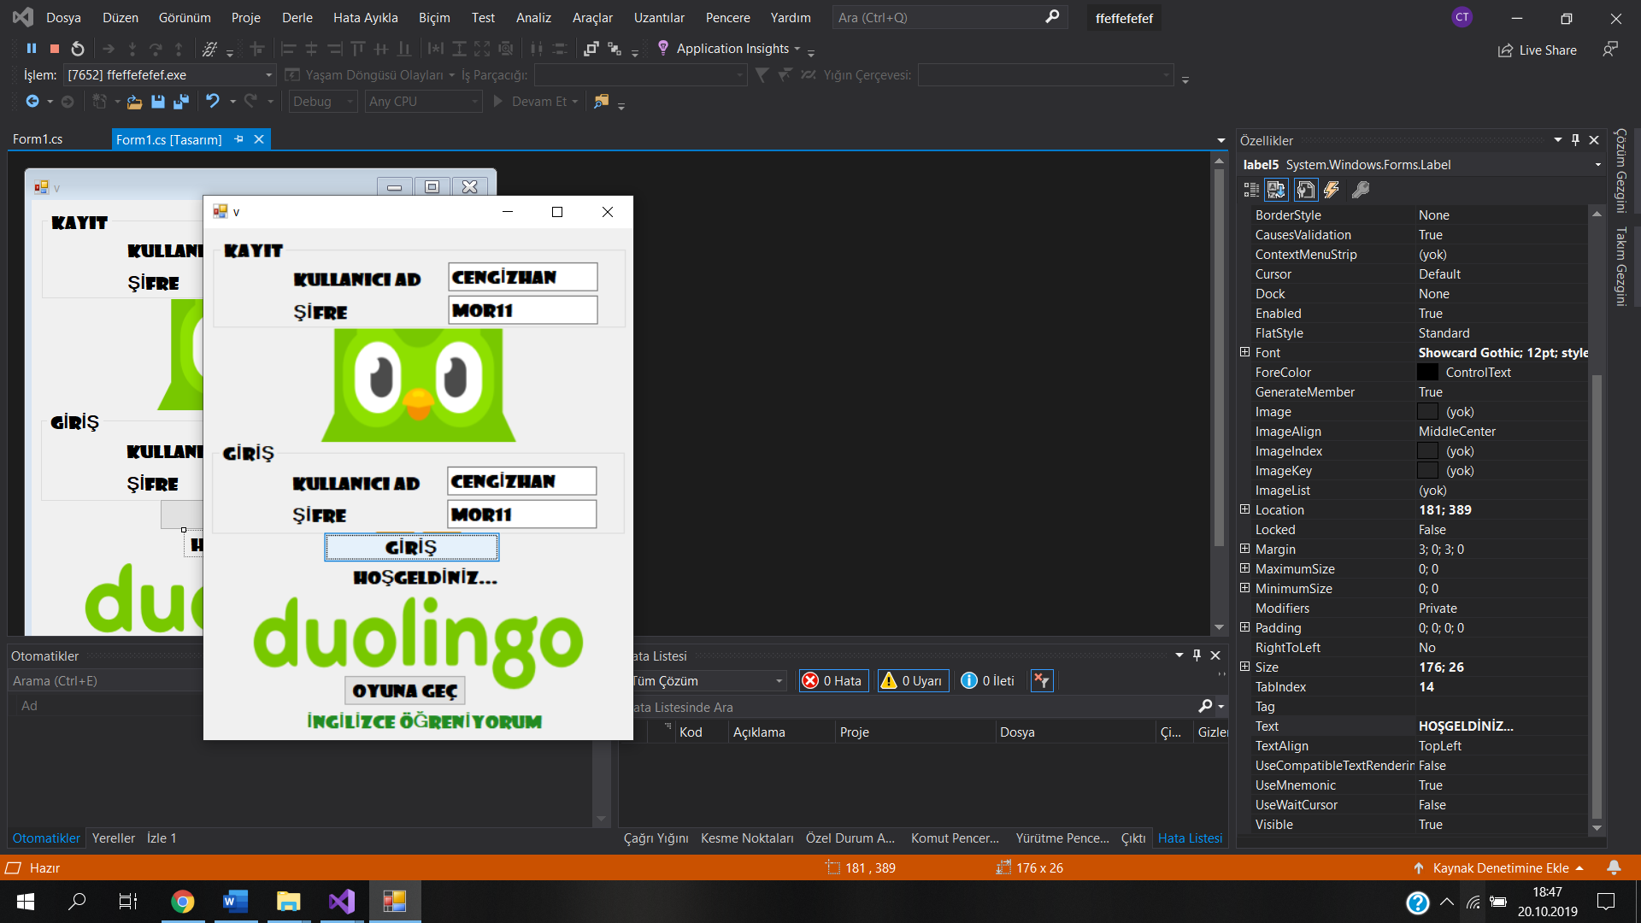

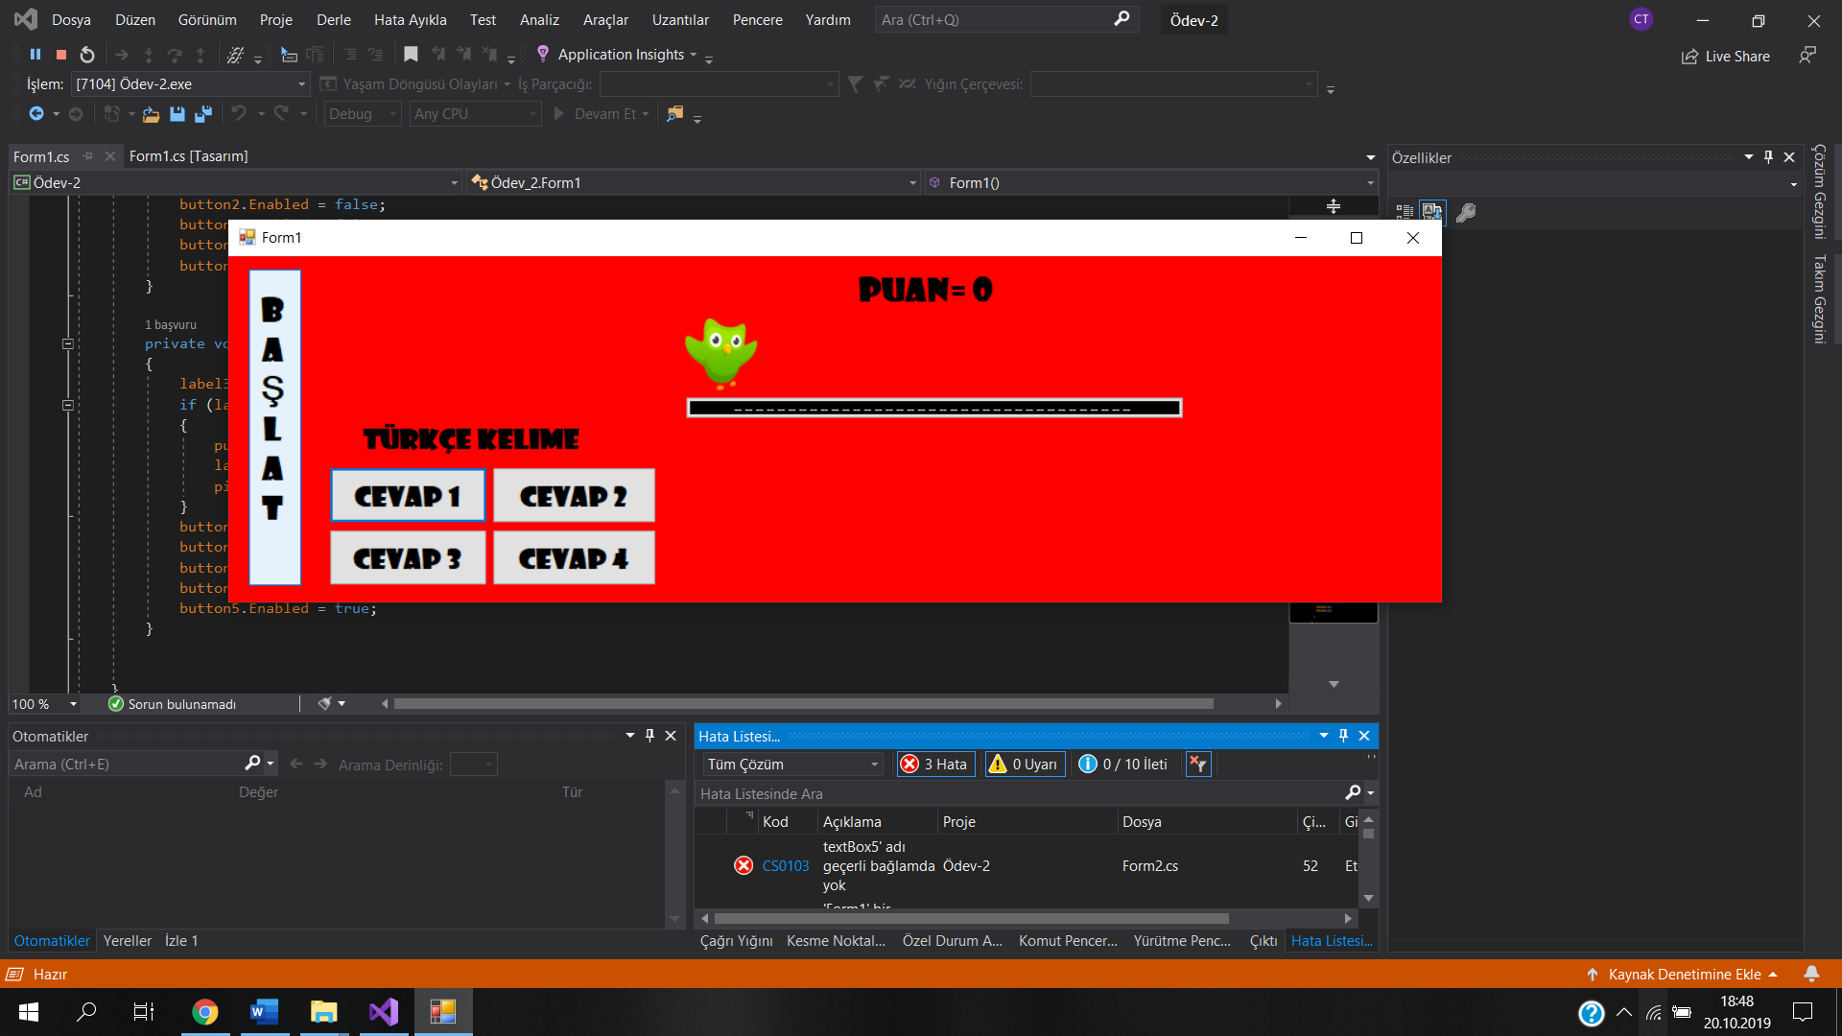

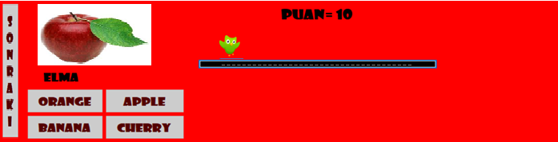

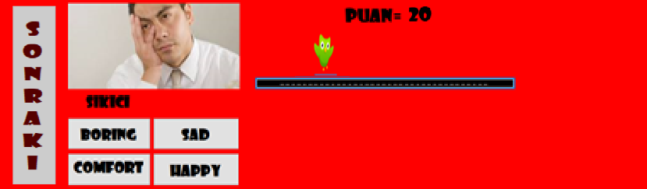

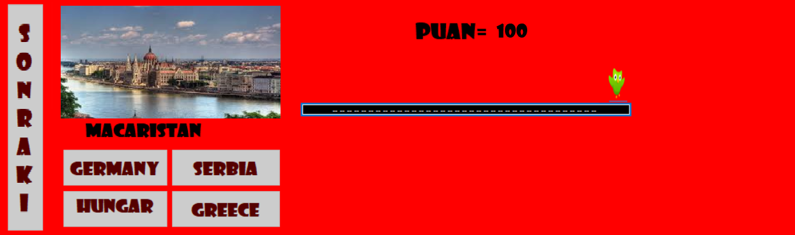

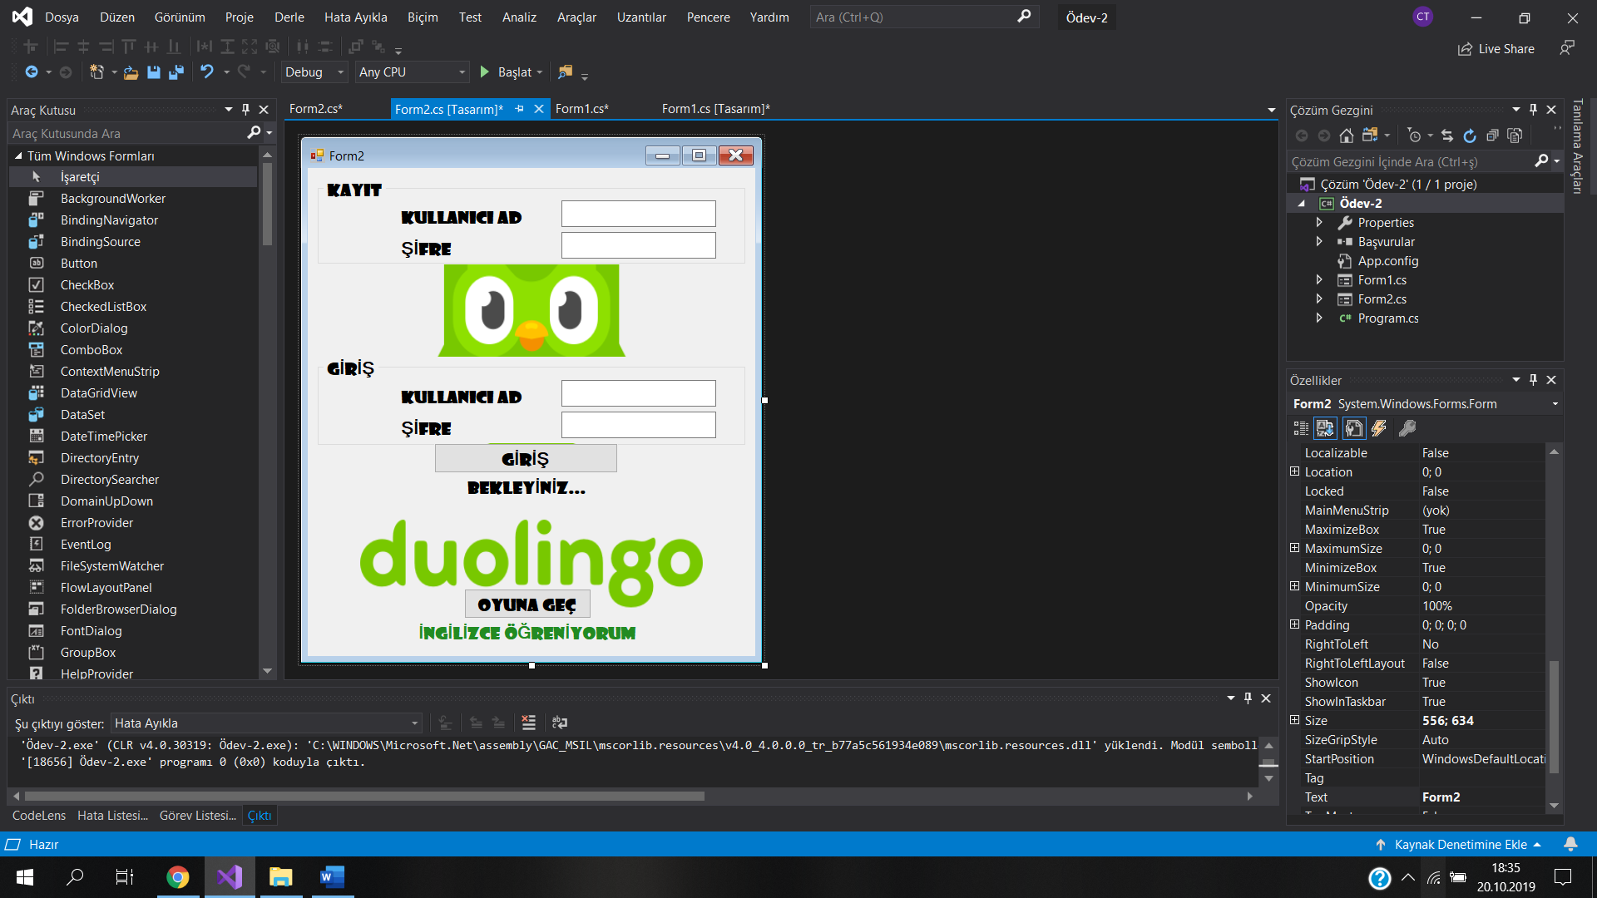

using System;

using System.Collections.Generic;

using System.ComponentModel;

using System.Data;

using System.Drawing;

using System.Linq;

using System.Text;

using System.Threading.Tasks;

using System.Windows.Forms;

using System.Collections;

namespace Ödev_2

{

public partial class Form2 : Form

{

public Form2()

{

InitializeComponent();

}

private void label5_Click(object sender, EventArgs e)

{

}

private void label6_Click(object sender, EventArgs e)

{

}

private void button1_Click(object sender, EventArgs e)

{

string kullaniciadi, sifre, kayitad, kayitsifre;

kullaniciadi = textBox3.Text;

sifre = textBox4.Text;

kayitad = textBox1.Text;

kayitsifre = textBox2.Text;

if (kullaniciadi==kayitad && sifre==kayitsifre)

{

label5.Text = "HOŞGELDİNİZ...";

}

else

{

label5.Text = "YANLIŞ GİRDİNİZ TEKRAR DENEYİNİZ";

}

}

private void button2_Click(object sender, EventArgs e)

{

string adsoyad = textBox5.Text;

Form1 YeniForm1 = new Form1();

YeniForm1.GelenBilgi = adsoyad;

YeniForm1.Show();

this.Hide();

}

}

}

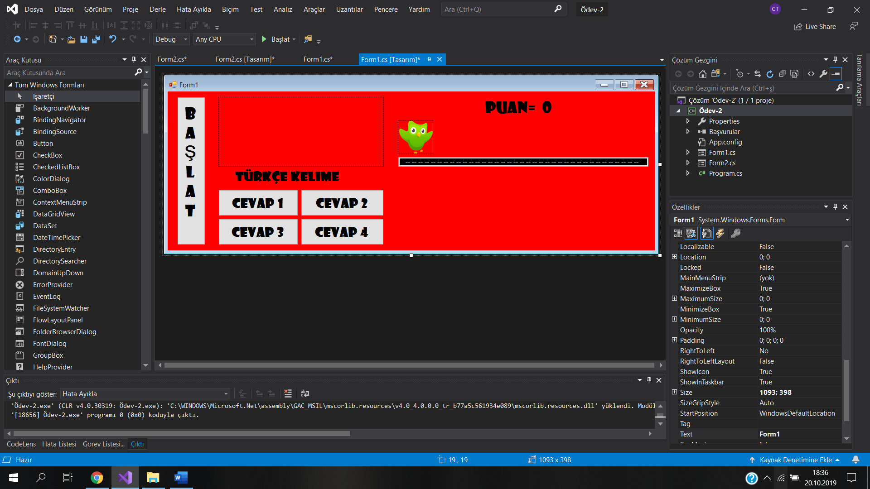

using System;

using System.Collections.Generic;

using System.ComponentModel;

using System.Data;

using System.Drawing;

using System.Linq;

using System.Text;

using System.Threading.Tasks;

using System.Windows.Forms;

namespace Ödev_2

{

public partial class Form1 : Form

{

public Form1()

{

InitializeComponent();

}

public string GelenBilgi = null;

int soru = 0;

int puan = 0;

private void button5_Click(object sender, EventArgs e)

{

soru++;

button5.Text = "Sonraki";

button1.Enabled = true;

button2.Enabled = true;

button3.Enabled = true;

button4.Enabled = true;

button5.Enabled = false;

if (soru==1)

{

label1.Text = "elma";

button1.Text = "orange";

button2.Text = "apple";

button3.Text = "banana";

button4.Text = "cherry";

label2.Text = "apple";

pictureBox1.ImageLocation = @"C:\Users\Cengizhan Topçu\Desktop\ingilizce - türkçe sözlük\elma.jpg";

}

if (soru==2)

{

label1.Text = "sıkıcı";

button1.Text = "boring";

button2.Text = "sad";

button3.Text = "comfortable";

button4.Text = "happy";

label2.Text = "boring";

pictureBox1.ImageLocation = @"C:\Users\Cengizhan Topçu\Desktop\ingilizce-türkçe sözlük\sıkıcı.jpg";

}

if (soru==3)

{

label1.Text = "mühendis";

button1.Text = "lawyer";

button2.Text = "doctor";

button3.Text = "nurse";

button4.Text = "engineer";

label2.Text = "mühendis";

pictureBox1.ImageLocation = @"C: \Users\Cengizhan Topçu\Desktop\ingilizce - türkçe sözlük\mühendis.jpg";

}

if (soru == 4)

{

label1.Text = "seçmek";

button1.Text = "make";

button2.Text = "do";

button3.Text = "happen";

button4.Text = "choose";

label2.Text = "choose";

pictureBox1.ImageLocation = @"C:\Users\Cengizhan Topçu\Desktop\ingilizce - türkçe sözlük\seçmek.jpg";

}

if (soru == 5)

{

label1.Text = "bardak";

button1.Text = "vase";

button2.Text = "glass";

button3.Text = "door";

button4.Text = "window";

label2.Text = "glass";

pictureBox1.ImageLocation = @"C:\Users\Cengizhan Topçu\Desktop\ingilizce - türkçe sözlük\bardak.jpg";

}

if (soru == 6)

{

label1.Text = "kurt";

button1.Text = "wolf";

button2.Text = "dog";

button3.Text = "cat";

button4.Text = "worm";

label2.Text = "wolf";

pictureBox1.ImageLocation = @"C:\Users\Cengizhan Topçu\Desktop\ingilizce - türkçe sözlük\kurt.jpg";

}

if (soru == 7)

{

label1.Text = "evlilik";

button1.Text = "marriage";

button2.Text = "divorce";

button3.Text = "pregnant";

button4.Text = "break up";

label2.Text = "marriage";

pictureBox1.ImageLocation = @"C:\Users\Cengizhan Topçu\Desktop\ingilizce - türkçe sözlük\evlilik.jpg";

}

if (soru == 8)

{

label1.Text = "hastane";

button1.Text = "grocer";

button2.Text = "post office";

button3.Text = "school";

button4.Text = "hospital";

label2.Text = "hospital";

pictureBox1.ImageLocation = @"C:\Users\Cengizhan Topçu\Desktop\ingilizce - türkçe sözlük\hastane.jpg";

}

if (soru == 9)

{

label1.Text = "tekerlek";

button1.Text = "car";

button2.Text = "wheel";

button3.Text = "mirror";

button4.Text = "stone";

label2.Text = "wheel";

pictureBox1.ImageLocation = @"C:\Users\Cengizhan Topçu\Desktop\ingilizce - türkçe sözlük\tekerlek.jpg";

}

if (soru == 10)

{

label1.Text = "Macaristan";

button1.Text = "Germany";

button2.Text = "Serbia";

button3.Text = "Hungary";

button4.Text = "Greece";

label2.Text = "Hungary";

pictureBox1.ImageLocation = @"C:\Users\Cengizhan Topçu\Desktop\ingilizce - türkçe sözlük\Macaristan.jpg";

}

}

private void button1_Click(object sender, EventArgs e)

{

label3.Text = button1.Text;

if (label2.Text==label3.Text)

{

puan = puan + 10;

label5.Text = puan.ToString();

pictureBox2.Left = -1;

}

button1.Enabled = false;

button2.Enabled = false;

button3.Enabled = false;

button4.Enabled = false;

button5.Enabled = true;

}

private void button2_Click(object sender, EventArgs e)

{

label3.Text = button2.Text;

if (label2.Text == label3.Text)

{

puan = puan + 10;

label5.Text = puan.ToString();

pictureBox2.Left = -1 ;

}

button1.Enabled = false;

button2.Enabled = false;

button3.Enabled = false;

button4.Enabled = false;

button5.Enabled = true;

}

private void button3_Click(object sender, EventArgs e)

{

label3.Text = button3.Text;

if (label2.Text == label3.Text)

{

puan = puan + 10;

label5.Text = puan.ToString();

pictureBox2.Left = -1;

}

button1.Enabled = false;

button2.Enabled = false;

button3.Enabled = false;

button4.Enabled = false;

button5.Enabled = true;

}

private void button4_Click(object sender, EventArgs e)

{

label3.Text = button4.Text;

if (label2.Text == label3.Text)

{

puan = puan + 10;

label5.Text = puan.ToString();

pictureBox2.Left = -1;

}

button1.Enabled = false;

button2.Enabled = false;

button3.Enabled = false;

button4.Enabled = false;

button5.Enabled = true;

}

private void Form1_Load(object sender, EventArgs e)

{

label6.Text = GelenBilgi;

}

}

}